DESIGN & FABRICATION OF LINE FOLLOWING ROBOT

By

MUSA FAHEEZAH AYOMIDE ANUOLUWAPO - 2024/13283

OBIAGA CHUKWUEMEKA JOSHUA - 2024/13257

OPARINDE ENOCH OLAYIWOLA - 2024/13277

OYEDEPO VICTOR EMMANUEL - 2024/13270

ADEYANJU OLUWASEYI - 2024/13271

ROBOTICS (BUT-ICT215) PROJECT

Submitted to New Horizon

Bells University of Technology

CHAPTER 1: Introduction
1.1 Background of the Study
A line follower is a simple robot that can find its way by tracking a line drawn on the ground. In the world of science, robotics has really taken off in recent years. The line-following robot came out early on as a hands-on solution for making machines move on their own. It works by using sensors—usually something basic like infrared—to spot a line (most times, a black line on a white background). The robot’s brain, often a microcontroller like Arduino, processes the sensor data and tells the motors when and how to steer back on course. This straightforward system has become the training ground for anyone learning about autonomous machines, whether in factories, classrooms, or just for fun.
Before the line follower, there was the Automated Guided Vehicle (AGV). Back in the 1950s, people started using these big, cable-guided carts in warehouses and factories. They weren’t robots as we think of them today, but they were the first step in that direction. The first real “robot” that could follow a line—something closer to what we picture now—showed up in the early 1970s. It had all the main parts we still use: line sensors, a control circuit, motors and actuators, a power source, and some kind of chassis to hold it all together. The electronics back then were clunky, but the idea was the same.

1.2 Problem Statement
People tend to avoid jobs that are boring and repetitive. Sure, there are already plenty of line-following robots out there—some analog, some digital—but there’s still room to make one that’s more accurate, efficient, and affordable. Building a better version isn’t just about saving money on parts. The process itself builds new skills and know-how for anyone working on it.

1.3 Objectives
The main goal here is to design and build a line-following robot that can move left, right, and forward along a black line on a white surface. It’ll use four simple DC motors with four wheels. Here’s what I want to achieve:

- Write the Arduino program to control the robot.
- To design and simulate the complete system using Proteus and Tinkercad
- To develop analog circuits for sensor interfacing and signal conditioning
- To write and optimize microcontroller code for real-time control
- To design a professional PCB layout
- To build and test the physical prototype
- To document the entire project and publish on GitHub

1.4 Research Questions
These are the questions I want to tackle in this study:
I. How can I improve the robot’s performance, like by tuning its PID controller or handling tricky paths?
II. What are the best ways to add intelligence, like object avoidance using AI or machine learning?
III. How can I boost its speed, efficiency, and power management?
IV. Where can line-following robots be used—healthcare, logistics, helping the elderly, or working in dangerous places?

1.5 Significance of the Study
This project matters for a bunch of reasons—academically, practically, and technologically. Designing and building a line-following robot is a solid way to learn how sensors, microcontrollers, and motors all work together inside an autonomous machine.
From the academic side, students get hands-on experience with key engineering ideas: working with analog signals, writing real-time control code, and figuring out how to connect theory to actual working systems. It’s a chance to turn classroom knowledge into real problem-solving skills.
On the tech side, line-following robots are already big in industry, especially for things like automatic material handling or warehouse logistics. This project lays out the basics behind those systems and sets the stage for more advanced stuff like obstacle avoidance, path planning, and smarter navigation.
By using simulation tools like Proteus and Tinkercad, it’s possible to test and tweak the design before building any real hardware. That saves money and cuts down on mistakes. Plus, creating a proper PCB and documenting everything on GitHub makes the project more reliable and easier for others to learn from. In the end, this study helps robotics education, encourages open-source sharing, and trains people with the skills needed in automation and embedded systems.

1.6 Scope and Limitations
Scope of the Study
This project covers a few key areas:
- Building a line-detection system using IR sensors.
- Creating analog signal conditioning circuits so the sensors work smoothly.
- Using a microcontroller to make decisions and control the motors.
- Simulating the whole setup in Proteus and Tinkercad.
- Designing and making a custom PCB.
- Putting together and testing a working robot prototype.
- Keeping all the work organized and tracked with GitHub.
The robot’s mainly meant for learning and lab work. It runs on a flat surface with a clear line to follow.

Limitations of the Study
While the project hits its main goals, there are some limits:
- The robot sticks to set line paths. It can’t wander around on its own or handle places without a visible line.
- The IR sensors can get confused by changes in room lighting, which could mess with performance.
- There’s nothing fancy like obstacle detection, wireless controls, or AI in this version.
- The motors and power supply put a cap on how fast the robot can go or how much weight it can carry.
- Tests only happen indoors, so it’s not really proven for rough industrial use yet.
These limits point out where future upgrades can happen.

1.7 Organization of the Study
The report breaks down into five chapters:
Chapter One: INTRODUCTION
Covers the project’s background, what problem it tackles, the goals, research questions, why it matters, and its scope and limits.
Chapter Two: LITERATURE REVIEW
Looks at what’s already been done with line-following robots, analog circuits, microcontroller choices, simulation tools, and PCB design. It also spots what’s missing in the current research.
Chapter Three: METHODOLOGY
Walks through the design and build process step by step—hardware, software, analog circuits, simulations, PCB work, making the prototype, and how testing was done.
Chapter Four: RESULTS AND DISCUSSION
Shows the results from both simulations and real hardware, compares PCB and breadboard performance, talks about how the findings fit with what’s already known, and explains any problems that popped up and how they were handled.
Chapter Five: CONCLUSION AND RECOMMENDATIONS
Wraps up the findings, shares the main takeaways, points out what the project adds to the field, and gives advice for industry use and where research could go next.

Chapter 2: Literature Review
2.1 Introduction
A line-following robot (LFR) is a self-driving robot that sticks to a path marked on the ground, usually a high-contrast line. It spots the line with sensors and keeps adjusting its movement to stay on course. LFRs are a big deal in robotics research and teaching, and they pop up in real-world jobs like warehouse navigation, automated guided vehicles (AGVs), and educational contests. The tough parts when building these robots are getting clean signals from the sensors, handling real-time control, designing circuits to drive the motors, and coming up with good path-tracking algorithms.
You’ll find line-followers in all sorts of places: factories, transport, home automation, and guiding systems. They’re handy for automating boring tasks, giving directions, and even spotting dangerous situations. Some common uses:
- Automated warehouses
- Assembly lines
- Delivery systems
- Car manufacturing
- Pick-and-place operations
Usually, a line-follower has sensors for spotting the line, a microcontroller to handle the data, and motors to make it move.
How does it work? The robot’s sensors (often IR sensors) keep looking for the line’s contrast with the background, and the robot constantly tweaks its speed and direction to stay lined up. The control circuit reads the sensor data, and the microcontroller sends commands to the motors through drivers—always working to keep the robot on track.

2.2 Review of Existing Similar Robots
1. Basic IR Sensor Line Follower – This is your classic design. It uses a row of infrared sensors to spot the line and steer the robot. Everything runs off a microcontroller, handling simple line detection and motion.
2. Microcontroller-Based Line Follower Using AVR – Here, they use an AVR microcontroller and add PID control. That means the robot tracks the path more accurately, still relying on IR sensors.
3. 8051 Microcontroller LFR – In this one, they switched to an ATmega or 8051 microcontroller. It reads the sensors and even gives feedback on an LCD screen.
4. Sensor-Based Black Line Follower without Microcontroller Logic – This design skips the microcontroller altogether. Instead, comparator networks and motor drivers handle the line following.
5. Analog/Non-Microcontroller Line Follower Robot – Everything’s analog here. Multiple IR sensors and basic circuits guide the robot—no microcontroller needed.
6. Line Follower with Enhanced Sensor Techniques – This one brings in better sensors for quicker detection and sharper responses.
7. Color and Android-Assisted Line Follower – They use a PIC microcontroller, add color sensors, and even let a smartphone help control the robot.
8. Adaptive Multi-Sensor Line Follower – This design adds ultrasonic sensors alongside IR. It can spot obstacles and adjust its path on the fly.
9. Vision-Assisted Line Follower – With computer vision, this robot sees the line using a camera, which is a big step up from just IR sensors.
10. PID Optimized Line Following Control – This approach focuses on tuning PID control for cheap line followers, squeezing out better performance.

All these designs show how you can go from simple analog circuits to advanced microcontrollers and even computer vision for line-following robots.

2.3 Analog Circuit Techniques in Robotics
Analog circuits play a big part in robotics, especially for handling sensors and giving quick responses without any software getting in the way. In line follower robots, analog electronics process sensor signals and run the motors directly:
- Comparator circuits turn sensor voltages into digital logic, so the robot knows if it’s on the line or not.
- Op-amps (operational amplifiers) boost and clean up the signals from sensors before anything else happens.
- Transistors and analog motor drivers (like simple BJT or MOSFET setups) let the robot control motor speed straight from those analog signals.
- Some BEAM robotics designs use plain analog networks to mimic simple animal-like reactions, letting the robot follow paths or dodge obstacles without any microcontroller at all.
Why use analog techniques? For one, they’re low-power and super fast since everything happens in hardware. They’re simple—perfect for basic systems where you don’t really need a computer. And for students, building with analog parts is a great way to learn circuit basics before moving on to microcontrollers.

2.4 Microcontroller Selection and Justification
A microcontroller really is the brain of a line following robot. It reads the sensors and calls the shots.
What do you look for when picking one?
1. Enough I/O pins for all your sensors and motor drivers.
2. ADC channels, so it can read analog sensor voltages (like from IR or phototransistor arrays), unless you’re using comparators.
3. Decent processing speed for real-time control and running algorithms like PID.
4. PWM outputs, so you can fine-tune motor speeds.
5. Good community support and reasonable cost—big platforms come with lots of libraries and examples, which makes your life easier.

Some popular choices:
- ATmega328 / Arduino Uno – Easy to use, has enough PWM and ADC channels, and there’s a huge online community. Great for beginners and intermediate projects.
- AVR microcontrollers (like the ATmega series) – Often show up in research, especially with PID control.
- PIC microcontrollers (e.g., PIC16F877A) – Tough and reliable for embedded stuff, with solid performance and built-in features.
- MSP430 series – Low power, which is perfect if you want your robot to sip energy.

Justification: Microcontrollers like the ATmega/AVR family hit the sweet spot. They offer digital control and come loaded with ADC and PWM features, so hooking up sensors and motor drivers is straightforward. They also make adaptive control (like PID) possible, so your robot can track lines more accurately than with just analog circuits.
In short, microcontrollers take sensor and button inputs, and send commands out to motor drivers or LCD screens—tying the whole robot together.

2.5 Use of Proteus and Tinkercad in Industry/Education
Simulation tools like Proteus Design Suite and Autodesk Tinkercad have become must-haves for both classrooms and industry labs. They let engineers and students see their circuits in action, test ideas, and catch mistakes before anyone touches real hardware. That’s a huge time-saver — and budgets love it.
A) Proteus Design Suite: Proteus stands out in the professional world, especially for microprocessor simulation and electronic circuit design (ISIS). What’s really powerful here is its ability to simulate both the hardware and the firmware at the same time. Designers can run and debug microcontroller code — say, Arduino code for a robot — right alongside the circuit schematic. This matters a lot for complicated projects with sensors, motors, and tricky power needs. You get to watch how your embedded code talks to the analog circuits and motor drivers, all before you’ve even made a PCB.
B) Autodesk Tinkercad: Tinkercad is usually seen as a beginner’s tool, but it’s surprisingly versatile. It’s a cloud-based platform where you can mess around with circuit simulation (using its Circuits feature) and do some basic 3D modeling. Take a project like a Line Following Robot — Tinkercad makes it easy to set up the basics: Arduino, motors, IR sensors, all wired together. The interface is simple, so you can quickly check if your idea actually holds up. It’s also perfect for teaching students how to wire up microcontrollers and get started with block-based coding.

2.6 PCB Design Trends in Robotics
PCB design for robotics is changing fast, especially in things like line-following robots or smart carts. Everything’s getting smaller, and designers want to cram more features onto a single board.
Miniaturization and Integration: You don’t see as many separate modules these days. Instead of an Arduino here, a motor board there, and a pile of wires connecting everything, engineers now pack the microcontroller, motor drivers (think surface-mount chips instead of those old-school L298N modules), and sensor circuits all onto one custom PCB. It looks cleaner, cuts down the mess of wires, and the signals don’t get as noisy. Plus, the whole thing is tougher and less likely to fall apart.
Signal Integrity for Sensors: If you’re building a line follower, sensor noise is a big headache. The IR sensor array can pick up interference from motors if you’re not careful. So, designers keep high-current motor traces away from sensitive sensor lines. They use fat copper traces for power so there’s no voltage sag, and a solid ground plane to keep things steady. It’s all about making sure the robot actually follows the line instead of getting confused by electrical junk.
Surface-Mount Technology (SMT): Through-hole parts are still around, mostly because they’re easier for beginners to solder. But in serious robotics work, SMT is everywhere. Smaller parts, smaller boards, and way easier to mass-produce. That’s just the way things are heading now.

2.7 Research Gap Identification
So, after digging through other line-following and smart cart projects, a few gaps really jump out. Here’s what this project wants to fix:
1) Lack of True System Integration: Most educational robots stick to the basics—PID algorithms, a couple of sensors, and big, off-the-shelf boards like the Arduino UNO. Hardly anyone builds a custom PCB that’s actually meant for tight integration of sensors and motors, or runs a proper simulation before soldering things together. This project is going for a real end-to-end design: custom PCB, simulation in Proteus, everything planned out before picking up a single component.
2) Missing Multi-Platform Simulation Workflow: Lots of people use Tinkercad for rough sketches or Proteus for deeper simulation, but there’s hardly any detailed reporting that shows how a project moves from one tool to the other. This project will lay that out clearly—Tinkercad for checking the basic schematic, then Proteus for full co-simulation and PCB planning. You get the whole picture, not just bits and pieces.
3) Smart Shopping Cart Functionality: Sure, line-followers are everywhere, but turning one into a real smart shopping cart—that’s rare. Most projects stop at following a line. This project goes further, combining navigation with things like object recognition, inventory, maybe even automated checkout. It’s not just a toy anymore; it’s aiming at real-world, industrial use.

CHAPTER 3: RESULTS AND DISCUSSION
3.1 System Block Diagram
A system block diagram is a high-level visual representation, using labelled blocks to represent functional units or components and arrows to show their relationship, data flow, or control flow. It simplifies complex systems by emphasizing how components interact rather than detailing their inner circuitry.
The below shows the system block diagram for the line following robot. It starts with IR sensors, which leads to the microcontroller, from there the motor driver which controls the motor. The power supply powers the whole system.

Motor driver
Microcontroller
IR Sensors

Power Supply
Motors

3.2 Hardware design
This chapter goes into detail about the process in designing and simulating the line following robot.

3.2.1 Analog Circuit Design
An analog circuit refers to circuits used to transmit, process, amplify, measure and display analog signals. It involves creating circuits that process continuous voltage or current signals, rather than discrete 0s and 1s, using components like resistors, capacitors, transistors, and operational amplifiers. Analog signals vary continuously, demanding high precision and signal integrity.

3.2.2 Microcontroller Selection & Pin Mapping
The microcontroller used is the one that comes with the Arduino Uno R3, which is the Microchip ATmega328P, an 8-bit AVR RISC-based microcontroller. It was chosen because it is affordable, low-power and versatile. It has 23 I/O pins, two 8-bit internal clocks, and 32kb of flash memory. It is commonly used in autonomous systems where a simple, low-powered, low-cost microcontroller is needed.
Pin Mapping
The pin mapping for the Arduino is as follows;
Arduino |  |  |  | Motor Driver (L293D)
Pin Number | Pin Name | Signal Type | Connected Too | Pin Number | Pin Name | Connected Too
0 | D0 | Not defined | - | 1 | Enable 1&2
1 | D1 | Not defined | - | 2 | Input 1
2 | D2 | Not defined | - | 3 | Output 1
3 | D3 | Not defined | - | 4 | Ground
4 | D4 | Not defined | - | 5 | Ground
5 | D5 | Input | Left IR Sensor | 6 | Output 2
6 | D6 | Input | Middle IR Sensor | 7 | Input 2
7 | D7 | Input | Right IR Sensor | 8 | Power 2
8 | D8 | Output |  | 9 | Enable 3&4
9 | D9 | Output |  | 10 | Input 3
10 | D10 | Output |  | 11 | Output 3
11 | D11 | Output |  | 12 | Ground
12 | D12 | Output |  | 13 | Ground
13 | D13 | Output |  | 14 | Output 4
A0 | A0 |  |  | 15 | Input 4
A1 | A1 |  |  | 16 | Power 1
A2 | A2
A3 | A3
A4 | A4
A5 | A5

3.2.3 Complete Schematic in Proteus

Below is the complete schematic of the line following robot that was done in Proteus 8 Professional.
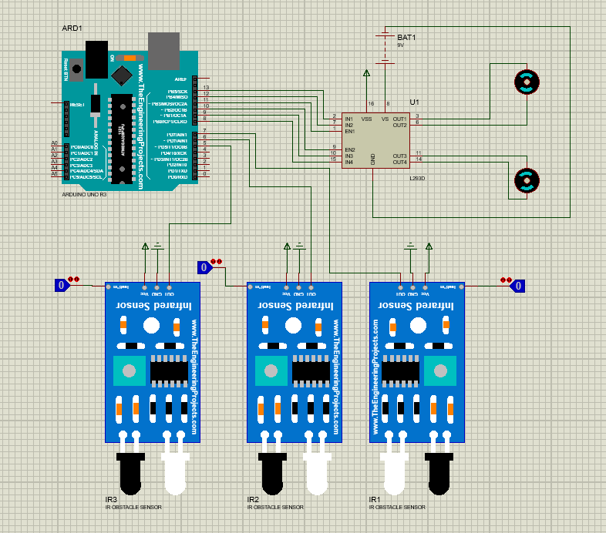

3.2.4 Simulation Results in Proteus
The line following robot uses 3 IR sensors which work as follows;
When the left sensor senses a black line the robot will turn left, when the right sensor senses a black line, the robot will go right, when the middle sensor senses a black line it will go straight, and there’s nothing the robot will stop.

3.2.5 Tinkercad 3D Simulation
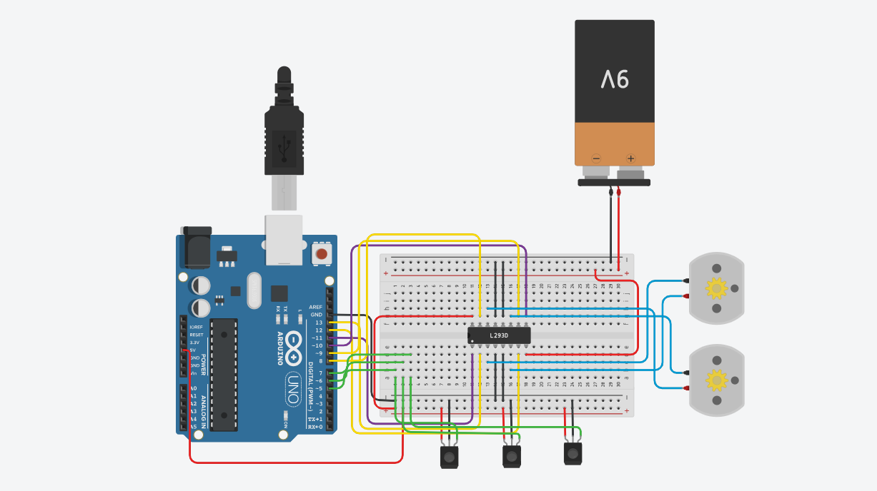
Above is the 3D simulation done in tinkercad. Each colored wire does a different task as mentioned below:
Red: Connection to power sources
Yellow: Connection between Arduino output pins and L293D input pins
Green: Connection between Arduino input pins and IR sensor output pin
Blue: Connection between L293D output pins and motors
Purple: Connection between Arduino output pins and L293D enable pins
Black: Connection to ground

3.3 PCB Design
PCB (Printed Circuit Board) design is the specialized engineering process pf creating a blueprint for the physical, electrical, and mechanical layout of electronic components on an insulating substrate. It translates a circuit schematic into a manufactured, functional board by determining component placement, routing conductive paths, and managing signal/power integrity.
Core stages of the PCB design process:
- Schematic Capture
- Pre-layout/Component definition
- Component placement
- Routing
- Ground and Power planes
- Design verification
- Manufacturing preparation

3.4 Software Development
Software development is the structured process of conceiving, designing, programming, testing, and maintaining software applications, frameworks, or components to meet specific user needs. It involves the entire Software Development Life Cycle (SDLC).
Algorithm:
Start
Middle sensor senses black line:
Yes – go forward
No – right sensor senses black line:
Yes – go right
No – left sensor senses black line:
Yes – go left
No – stop

Flowchart:

Start

Middle sensor detects black line
Go forward

Right sensor detects black line
Go Right

Left sensor detects black line
Go Left

No sensor senses anything
Stop

CHAPTER 4: RESULTS AND DISCUSSION
4.1 Simulation Results
In the following screenshots, we use a test pin to simulate the sensor detecting a black line. The blue dots represent low, while the red dots represent high.

Going left:
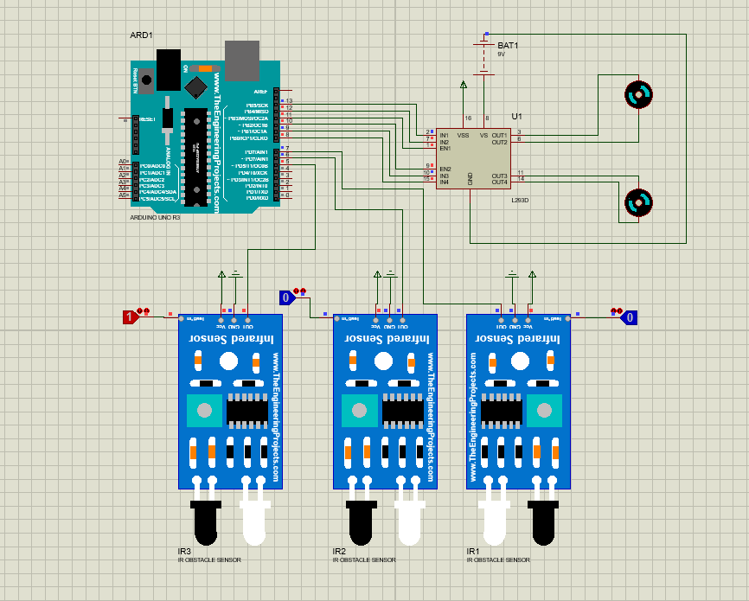
The left sensor senses a black line and, sends the high signal to pin 5. In doing this, the output pins 12 and 8 send a high signal while, 13 and 9 send a low one, which turns the motor left according to the Arduino code.

Going right:
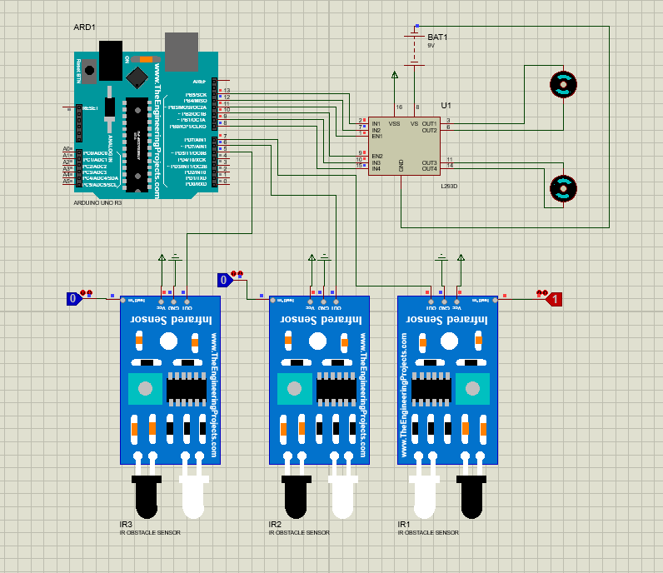
The right sensor senses a black line and, sends the high signal to pin 7. In doing this, the output pins 13 and 9 send a high signal while, 12 and 8 send a low one, which turns the motor left according to the Arduino code.

Going forward:
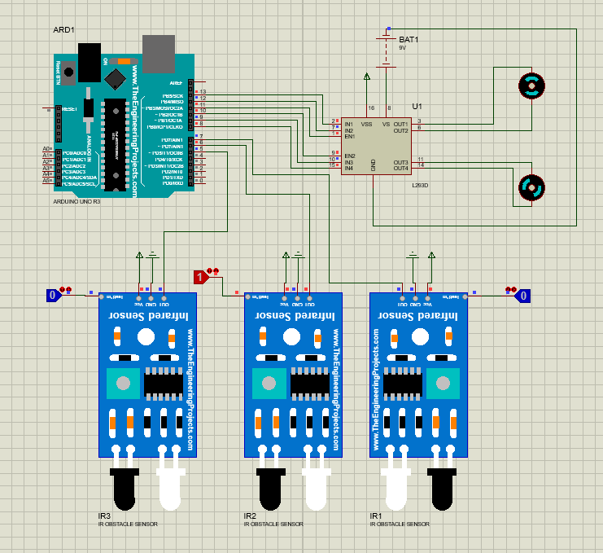
The middle sensor senses a black line and, sends the high signal to pin 7. In doing this, the output pins 13 and 8 send a high signal while, 12 and 9 send a low one, which turns the motor left according to the Arduino code.

Wait:
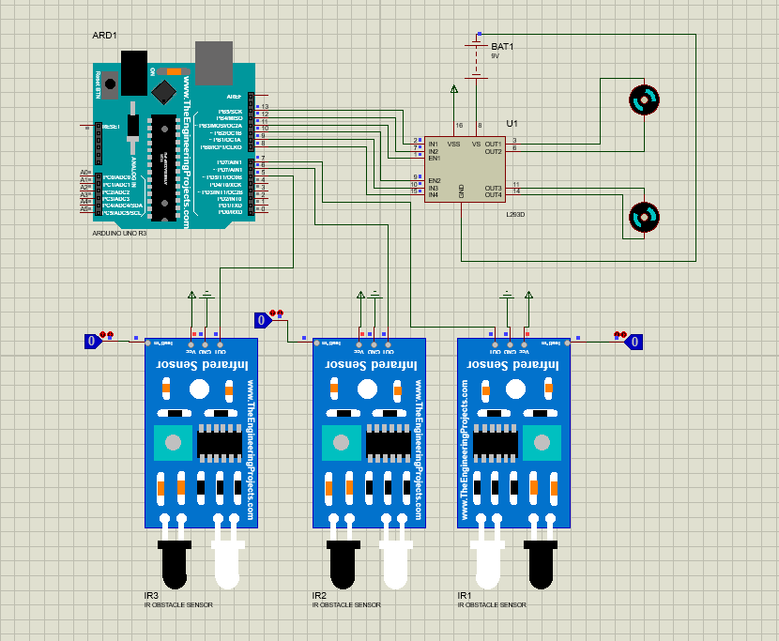
No sensor senses a black line and, only low signals are sent. In doing this, all the output pins send a low signal, which stops the motor from moving, according to the Arduino code.

CHAPTER 5: CONCLUSION AND RECOMMENDATIONS
5.1 Summary of Findings
This chapter represents the summary of the work undertaken, the conclusions drawn and the recommendations made as an outgrowth of this project. This project is about the process of building a line following robot.
The findings of this project were:
- How the line following robot works
- The best materials to use for it
- Its primary functions
- How to build it
5.2 Conclusion
In this report, there was an introduction into the history and background of line following robots, a review of already existing ones, a methodology showing the process of building the robot, and testing.

5.3 Limitations
Line following robots are primarily limited by their reliance on fixed, high contrast paths, making them incapable of navigating complex or dynamic environments.
Key limitations:
- Fixed path dependency
- Sensor limitations
- Physical limitations
- Speed vs. Accuracy
- Inability to detect obstacles

References
[1] High Performance Line Follower Robot - Instructables
[2] Review Article: Line Following Robots
[3] Line Follower Robot using Arduino UNO: A Complete Step-by-Step Guide (Beginner Friendly)
[4] College Road
[5] mBot Line Follower Reviewed – YouTube
[6] https://share.google/5HtvXF6OGb41r4wi1
[7] Line Follower Robot - Build it from scratch - EmbedJournal
[8] The line follower robot: a meta-analytic approach - PMC - PubMed Central
[9] Line follower robot using microcontroller
[10] Which micro-controller is better to build a line follower robot? – Quora
[11] https://en.wikipedia.org/wiki/ATmega328#:~:text=ATmega328%20is%20commonly%20used%20in,cost%20micro%2Dcontroller%20is%20needed.
[12] https://www.linkedin.com/pulse/20-typical-analog-circuits-design-diagrams-kuke-electronics-v45jc
[13] Source: Altium https://share.google/HLUOUCMXAThiYJe74
[14] https://www.ijraset.com/best-journal/path-finder-autonomous-robot

Appendices
Arduino code:
void setup() {
pinMode(5, INPUT);
pinMode(6, INPUT);
pinMode(7, INPUT);
pinMode(8, OUTPUT);
pinMode(9, OUTPUT);
pinMode(10, OUTPUT);
pinMode(11, OUTPUT);
pinMode(12, OUTPUT);
pinMode(13, OUTPUT);
}

void loop() {
int r = digitalRead(7);
int l = digitalRead(5);
int m = digitalRead(6);
if (l == 0 && r == 0 && m == 1){
Forward();
}
if (l == 0 && r == 1 && m == 0){
Right();
}
if (l == 1 && r == 0 && m == 0){
Left();
}
if (l == 0 && r == 0 && m == 0){
Wait();
}
}
void Forward(){
//motor 1
digitalWrite(13, HIGH);
digitalWrite(12, LOW);
analogWrite(11,255);
//motor 2
digitalWrite(8, HIGH);
digitalWrite(9, LOW);
analogWrite(10,255);
}
void Left(){
//motor 1
digitalWrite(12, HIGH);
digitalWrite(13, LOW);
analogWrite(11,255);
//motor 2
digitalWrite(8, HIGH);
digitalWrite(9, LOW);
analogWrite(10,255);
}
void Right(){
//motor 1
digitalWrite(13, HIGH);
digitalWrite(12, LOW);
analogWrite(11,255);
//motor 2
digitalWrite(9, HIGH);
digitalWrite(8, LOW);
analogWrite(10,255);
}
void Wait(){
//motor 1
digitalWrite(13, LOW);
digitalWrite(12, LOW);
analogWrite(11,0);
//motor 2
digitalWrite(8, LOW);
digitalWrite(9, LOW);
analogWrite(10,0);
}

